Jason Maia

**Vampy the Vampire!**

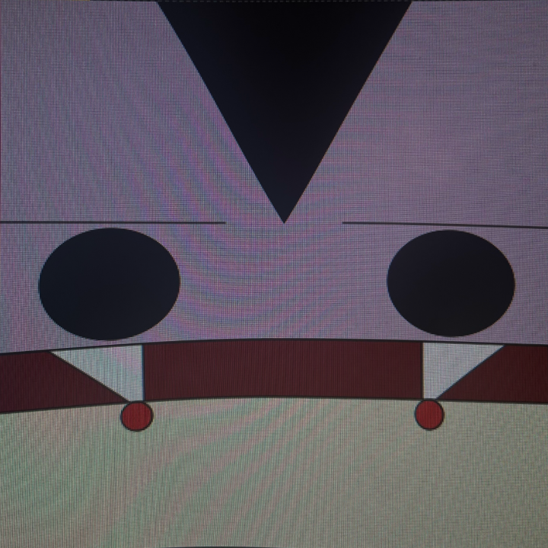

Introducing Vampy the Vampire! Vampy is an adorable vampire created in P5JS using coding techniques. By moving your mouse up and down, Vampy will open his mouth and bite down on an arm ahead of him! His face follows your mouse, so the faster you move it, the faster he’ll bite! This story has a simple theme of vampires and what they do best!

**Code to use in P5JS**

*//Jason Maia*

*//Huynh,P.*

*//Web and FX s.00001*

*//Vampy the Vampire!*

*//https://editor.p5js.org/jasonmaia07/full/q-6p687Mt*

*/* (Instructions)*

*Move your mouse up and down to visualize Vampy biting down and sucking blood from an arm!*

*(Analysis/artist statement)*

*This interaction shows our beloved vampire, Vampy, chowing down on another victim, sucking their blood!*/*

*function setup() {*

*createCanvas(400, 400);*

*}*

*function draw() {*

*//skin//*

*background(216,191,216);*

*//lips//*

*line(0,mouseY,400,mouseY);*

*//mouth//*

*fill(139, 0, 0);*

*square(0,mouseY,400);*

*//teeth//*

*fill(255,255,255);*

*triangle(30, mouseY, 90, mouseY, 90, mouseY+50);*

*triangle(370, mouseY, 310, mouseY, 310, mouseY+50);*

*//eyes//*

*fill(0,0,0);*

*circle(70,mouseY-50,90);*

*circle(330,mouseY-50,90);*

*//eyebrows//*

*line(0,mouseY-100,150,mouseY-100)*

*line(250,mouseY-100,400,mouseY-100)*

*//hair//*

*fill(0,0,0)*

*triangle(100,0,300,0,200,mouseY-100)*

*//arm//*

*fill(245, 245, 220)*

*square(0,300,400)*

*//injuries//*

*fill(215,0,0)*

*circle(315,310,20)*

*circle(85,310,20)*

*}*